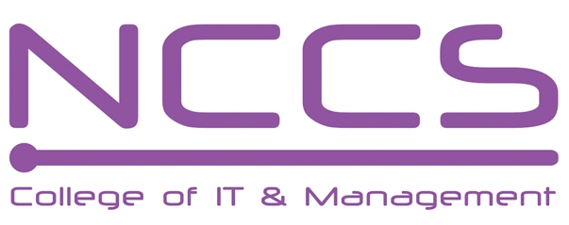
National College of Computer Studies
(NCCS-College of IT & Management)
Final Examination (2021)
BSc.CSIT/First Semester/ CSC 111 : Digital Logic

Candidates are required to answer the questions in their own words as far as practicable.

Full Marks: 60
Pass Marks: 30
Time: 3 Hours
Set B

Attempt any two questions. [2×10=20]
- What are asynchronous counter? Design synchronous Decade counter using T Flip-flop.
- Design and Explain Decimal adder.
- Implement the following functions using a. Multiplexer b. Decoder c. PAL
F(A,B,C,D)=∑(0,1,2,4,7,8,10,14)

Attempt any eight questions. [8×5=40]
- If A=-19 and B=-20 then perform A-B and B-A using 2’s complement
- If F(P,Q,R,S)=𝜋(0,1,4,5,11,14,15) and d(P,Q,R,S)= 𝜋(2,3,7,8,9,13),Simplify it using K- Map and design circuit using minimum number of NAND gates.
- Design 1x8 DEMUX using NOR gate only.
- Design a full adder circuit using Programmable Logic Array.
- Implement a circuit which accepts 3 bit binary input and output exceed five times the input by 2 using ROM.
- Design and Explain 3-bit Parallel In Serial Out Shift Register along with Timing diagram.
- Design asynchronous MOD-12 counter with state diagram, logical diagram and timing diagram.
- Explain about the flip-flop which is single input version of JK flip-flop with logical diagram, characteristics table, characteristics equation and excitation table.
- Write short notes on (any two):
  - Transition Table
  - Ring counter
  - Error Detection Codes

********

